Government constitutes a committee to prepare the final draft of National Education Policy

The committee for preparation of final draft of National Education Policy has been constituted under the Chairmanship of eminent Scientist Padma Vibhushan Dr K. Kasturirangan. The other members of the committee are:
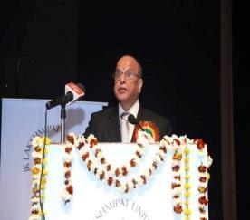

- Dr. Vasudha Kamat a prominent academician from the field of education technology who has contributed extensively towards school education.

- She was also Vice-Chancellor of SNDT University Mumbai

- Shri K.J. Alphonse holds administrative experience of practical challenges in implementation of school education reforms.

- He was instrumental in achieving 100 % literacy rate in Kottayam and Ernakulam districts of Kerala.

- Dr. Manjul Bhargava a Professor of Mathematics in Princeton University USA.

- He was awarded field medal in mathematics at a quite young age for his contributions to Gauss number theory.

Kenneth I Juster to be next US Ambassador to India

Senior White House official Kenneth I Juster, a top aide of US President Donald Trump, is set to become America's next Ambassador to India.
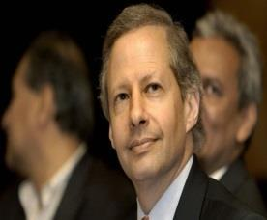

- The announcement regarding the appointment was made by White House on 21 June 2017.

- Once nominated and confirmed by the US Senate, Juster will succeed Richard Verma.

- Verma, the first Indian-American to head this position, put in his papers when Trump replaced Barack Obama as the President of the United States.

- Presently, Juster is serving as the Deputy Assistant to the US President for International Economic Affairs and as Deputy Director of the National Economic Council in the White House.

- He served as Deputy Secretary of Commerce in President George W Bush’s administration.

- As a Commerce Secretary, he launched the High Technology Cooperation Group to promote trade in sensitive dual-use goods and technology.

NATIONAL
NEWS

NATIONAL
NEWS

18 sections, 2 rules for GST notified

Few days ahead of the rollout of the GST Act across India, the Union Government on 20 June 2017 notified sections in the GST Act dealing with mandatory registration of current indirect taxpayers in the new regime.
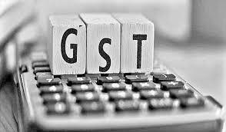

- It has notified as many as 18 sections related to registration of current central excise, service tax and VAT payers with the GST-Network (GSTN) as well as transitional provisions.

- As a precursor to GST, the Central Board of Excise and Customs (CBEC) has also notified two rules relating to registration and composition levy.

- All the notifications will come into effect on 22 June 2017. GST, which is to be rolled out from 1 July 2017, will unify over a dozen central and state levies into one.

- Every business carrying out a taxable supply of goods or services with a turnover exceeding the threshold limit of 20 lakh rupees will be required to register.

Bengaluru firm 1st in India to deliver diesel at home

The 'dieselwallah' is here. Bengaluru has become the country's first city where one can have fuel delivered at one's doorstep, just like milk and newspapers, only weeks after oil ministry announced that the Centre was thinking of rolling out such a system.
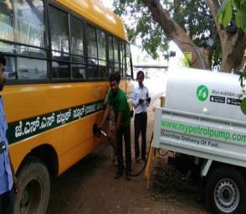

- On June 15, Mypetrolpump, a one-year-old startup, conducted a soft launch with three delivery vehicles -each with a capacity of 950 litres.

- It has already delivered more than 5,000 litres of diesel.

- Diesel is delivered at the day's running price with a fixed delivery charge.

- For up to 100 litres, the one-time delivery charge is `99. Above 100 litres, one needs to pay the diesel price plus one additional rupee per litre.

- The startup has got 20 odd customers, including 16 schools (which have 250-300 buses) and a few apartments.One can place orders online, through a phone call or by downloading the free app.

Aadhaar is Mandatory for TB Patients Seeking Government Cash Benefits
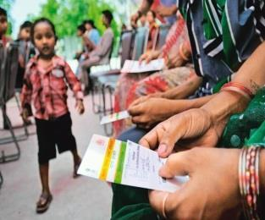
The Union health ministry has made Aadhaar a compulsory document for tuberculosis patients availing treatment under the government’s Revised National

Tuberculosis Control Programme (RNTCP).

NATIONAL
NEWS

NATIONAL
NEWS

NATIONAL

NEWS

- According to the government notification, “An individual eligible to receive the benefit under the Scheme, is hereby, required to furnish proof of possession of Aadhaar number or undergo Aadhaar authentication.”

- The notification says that the scheme offers conditional cash assistance as a benefit.

- The beneficiaries include TB patients, private health care providers and treatment supporters. The RNTCP says it aims to provide “universal access to tuberculosis care.”

- India has 2.8 million cases of TB as of the data from 2015. This data was in fact revised by the WHO because India had been under-reporting TB.

- In 2015 alone, 6.1 million new TB cases were reported to the WHO as India had been reporting only 59% of TB cases until then.

- However, several health workers say they were never informed of this cash assistance and TB patients have not been availing of it in the first place.

- They also see this order for mandatory Aadhaar cards as a way in which TB patients could be excluded and denied care.

Trains to clock 160 kmph on way to Delhi from Mumbai, Howrah
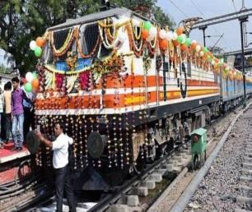
After the successful launch of Gatimaan Express, the Railways has undertaken a mammoth exercise of reducing journey time on the Delhi-Howrah and Delhi-Mumbai routes by increasing the speed of trains up to 160 km per hour at an estimated cost of Rs. 10,000 crore.

- “We have firmed up an action plan to increase the train speed up to 160 km per hour on the total 9,000-km main trunk routes across the country as part of the Mission Raftaar project.

- To begin with, we have started the work on two major busy routes of Delhi-Mumbai and Delhi-Howrah,” said a senior Railway Ministry official involved in the project.

- Railways has recently introduced Gatimaan Express between Delhi and Agra at 160 km per hour speed.

- Strengthening of the track, upgrading of signalling system and fencing off vulnerable sections along the route are to be undertaken to ensure the speed on the two busy corridors, as per the plan.

- While the Delhi-Howrah route is used by about 120 passenger trains and around 100 goods trains every day, some 90 passenger services and an equal number of freight trains run on the Delhi-Mumbai corridor daily.

NATIONAL
NEWS

In a first, UNICEF appoints Syrian refugee Muzoon Almellehan as Goodwill Ambassador

United Nations Children's Fund (UNICEF) on 19 June 2017 announced the appointment of Muzoon Almellehan, a 19-year-old education activist and Syrian refugee, as its newest and youngest Goodwill Ambassador.

- The appointment makes Muzoon the first person with official refugee status to become an Ambassador for UNICEF.

- In a first, UNICEF appoints Syrian refugee Muzoon Almellehan as Goodwill Ambassador
- Muzoon Almellehan fled the conflict in Syria along with her family in 2013.

- She lived as a refugee for three years in Jordan before being resettled in the United Kingdom.

- It was during her 18 months in the Za’atari refugee camp in Jordan that she began advocating for children’s access to education, particularly for girls.

- The United Nations International Children's Emergency Fund was created by the United Nations General Assembly on 11 December 1946.

Boris Becker, former Wimbledon champion, declared bankrupt by British court
Boris Becker was declared bankrupt by a British court on Wednesday after the former tennis player failed to pay a long-standing debt.

- A lawyer for the six-time Grand Slam champion pleaded with a Bankruptcy Court registrar in London for a last chance to pay a debt that Becker has owed to private bankers Arbuthnot Latham & Co. since 2015.

- The registrar, Christine Derrett, said there was a lack of credible evidence that his debt would be paid soon. She refused to adjourn the case for a further 28 days and announced a bankruptcy order.

- “One has the impression of a man with his head in the sand,” said the registrar, who said she watched Becker play on Centre Court at Wimbledon.

- The 49 year old Becker, who was born in Germany and lives in London, recently coached Novak Djokovic and has been a TV commentator.

GLOBAL NEWS

SPORTS

