CBSE Sets up Two Panels to Study Loopholes in Evaluation Process
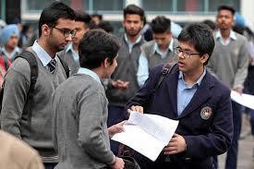

Amid complaints by students of evaluation faults in their class XII results, the CBSE on Tuesday set up two committees to study the loopholes in the evaluation procedure. A senior CBSE official said:

  - The board has taken a prompt decision to set up two committees comprising senior officers to look into the problems related to the evaluation processes being followed.

- The first committee will “enquire into the evaluation process and post examination processes to identify and analyse discrepancies, and suggest corrective measures to strengthen the process.”

- On the other hand, the second committee will “study, analyse and suggest systemic improvements in the evaluation process to make the system robust.” The official added

- The two committees will submit their report within two and three months respectively. On basis of the findings and suggestions of the committees, major changes may be introduced in the evaluation process.

- Amid complaints by students that they have suffered due to “faults” in the evaluation process, the CBSE had on Monday admitted that “in spite of the best efforts made by the experienced subject teachers, there may be possibilities of human error in transferring marks to the title page of the answer scripts, summation of marks and manual posting of marks in the computer system.”

From 2018 CBSE Board Exams will be Held in the Month of Feb
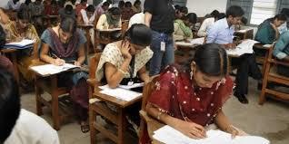

Central Board of Secondary Education (CBSE) has framed new schedule for the Board exams of session 2018-19.

- CBSE Board has planned to change the timetable of Class 10 and 12 Board exams from the

upcoming session.

- As per the new policy of CBSE, the Board exams of 10th and 12th will be conducted one month ago from 2018.

- From 2018, students of CBSE Board will have to give Board exams in the month of February instead of March.

- According to the official of CBSE Board, the decision will not affect the students as most of them take preparatory leave from the month of January only.

- It has also been said that the decision will also enable smooth and correct evaluation of the answer sheet of Board exams.

- Every year CBSE use to conduct Class 10 and 12 Board exam from the month of March to mid-April that even extends upto last of April.

NATIONAL
NEWS

NATIONAL
NEWS

- But from the new session of CBSE Board, the Board exams are likely to be carried out from 15 February 2018.

- It is also expected that after the 2018 schedule of CBSE Board exams, the exams will be over by the month of March.

Ministry of Tourism releases ‘Compendium on guidelines for Ayush

facilities’

The Ministry of Tourism has released the „Compendium on Guidelines for Ayush Facilities‟ here today.

- The National Medical & Wellness Tourism Board under the chairmanship of Minister for Tourism Dr. Mahesh Sharma has been repeatedly stressing on the need for

benchmarking of facilities offered by the various service providers in the field of Medical and Wellness Tourism on the basis of globally accepted standards.

- The constant endeavour of the Ministry of Tourism has been to promote institutions and processes that have achieved such standards in order to provide excellence in service quality.

- On the demand from the industry and stakeholders including Ministry of Tourism; the National Accreditation Board for Hospitals and Healthcare Providers (NABH) has brought out accreditation standards and guidelines for AYUSH facilities in the country including Wellness Centres and Panchkarma clinics that are used by tourists.

- The Ministry of Tourism under the direction of the Minister of Tourism Dr Mahesh Sharma has therefore compiled the accreditation standards for the various AYUSH facilities and urged the industry for wide acceptance of these standards.

- The compendium includes accreditation available for the following facilities.

- Ayurveda Hospitals

- Yoga and Naturopathy Hospitals

- Unani Hospitals

- Sidha Hospitals

- Homeopathy Hospitals

- Panchkarma Clinics

- Wellness Centres

NATIONAL
NEWS

UP gets 70,784 more houses for urban poor under PMAY(Urban)
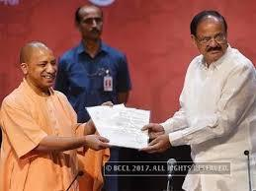

Ministry of Housing and Urban Poverty Alleviation has approved construction of 70,784 affordable houses for the benefit of urban poor in Uttar Pradesh under the Pradhan Mantri Awas Yojana (Urban) with an investment of Rs.3,528 cr for which central assistance of Rs.1,062 cr has been

approved.

- Further to the discussion Minister of HUPA Shri M.Venkaiah Naidu held with the Chief Minister of Uttar Pradesh Shri Yogi Adityanath soon after assumption of office, the State Government sent affordable housing proposals for 145 cities and the same have been approved.

- Earlier, Uttar Pradesh has been sanctioned 41,954 houses including those approved under Rajiv Awas Yojana, which has been now subsumed under PMAY(Urban).

- With these latest approvals, the total number of houses sanctioned for Uttar Pradesh has increased to 1,12,738.

- Of the 70,784 houses approved, 56,839 will be constructed under the Affordable Housing in Partnership component and 13,945 houses under Beneficiary Led Construction component of PMAY(Urban).

- Under these two components, central assistance of Rs.1.50 lakh is given to each beneficiary.

Top-level bureaucratic reshuffle: Rajiv Gauba to be next Union Home Secretary
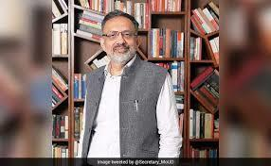

The Appointments Committee of the Cabinet (ACC) on 21 June 2017 approved various appointments leading to the major top-level bureaucratic reshuffle.

  - A total of 16 secretaries were appointed for various Union Government Departments.

- Urban Development Secretary Rajiv Gauba was named as the next Union Home Secretary.

- He will succeed Rajiv Mehrishi, who will complete his term on 30 August 2017.

- Gauba, a 1982 batch IAS officer of Jharkhand cadre, will take over as Officer on Special Duty (OSD) in the Union Home Ministry with immediate effect.

- Durga Shanker Mishra will replace Rajiv Gauba as the Urban Development Secretary. He is the Additional Secretary in the same ministry.

- Culture Secretary N K Sinha will be the Information and Broadcasting Secretary in place of Ajay Mittal, who will now be the DoPT secretary.

NATIONAL
NEWS

NATIONAL

NEWS

India to become most populated country in the world by 2024, says UN report
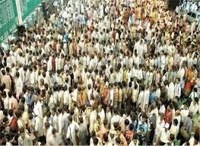

In roughly seven years, around 2024, the population of India is expected to surpass that of China, according to a UN report – the World Population Prospects: The 2017 Revision--published by the United Nations Department of Economic and Social Affairs.

- The report stated that currently, China with a population of about 1.41 billion and India with a population of about 1.34 billion are two of the most populous countries comprising 19 and 18 percent of the total global population.

- The 2017 Revision of World Population Prospects is the 25th round of official UN population estimates and projections. In its 24th round of estimates released in 2015, it was projected that the population of

India will surpass that of China‟s by 2022.

- By 2024, India and China are expected to roughly have a population of about 1.44 billion each.

- After that, India‟s population is projected to continue growing and touch 1.5 billion in 2030 and approach 1.66 billion by 2050, while

China‟s population is projected to remain stable until the 2030s, after which it may begin a slow decline.

ISRO launches Cartosat-2 along with 30 nano-satellites from Sriharikota
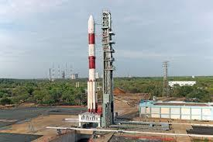

The National space agency, Indian Space Research Organisation (ISRO), on 23 June 2017 successfully launched India‟s „Cartosat-2 Series‟ satellite and 30 other co-passenger payloads.

  - The satellite and its co-passengers were launched by its highly reliable polar satellite launch vehicle PSLV C-38 from the Satish Dhawan Space Centre, Sriharikota at 9.29 am.

- This was the 40th flight for PSLV, the satellite launch vehicle and the 17th flight of PSLV in XL configuration with the use of solid strap-on motors.

- The PSLV C38 rocket carrying India‟s Cartost-2 Series satellite along with its co-passenger was launched after a 28-hour countdown that started at 5.29 hours on 22 June 2017.

- To give enough thrust to carry them to a 505 km sun-synchronous orbit, the rocket was armed with solid strap-on motors.

NATIONAL NEWS

SPACE SCIENCE

Regional Poets sweep up 16 Sahitya Academy Awards
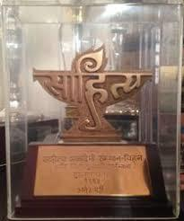

The Sahitya Akademi Yuva Puraskar 2017 was dominated by regional language poets, who took away sixteen awards for their exceptional poetry works.

- The other awardees included five authors for short stories, two for biographies and one for essay.

- All the recipients would be facilitated with the

Puraskar at a special function that is scheduled to be AWARDS organised on 14 November 2017. The award would be presented in

the form of a casket comprising an engraved copper plaque and a cheque worth Rs 50000.

- Assamese poet Pratim Baruah was honoured with the award for his work, Xodhahe Nohol Tok o Bokul.

- Bodo poet Bijit Gwra Ramchiary also won the award for his book on poetry titled 'Gwrbwni Aroj'.

- Hindi poet Taro Sindik also won an award for his book on poetry titled

„Aksharo Ki Vinti‟.

- Other poets who got the award included Rajinder Ranjha (Dogri), Kh.Krishnamohan Singha (Manipuri), Nighat Sahiba (Kashmiri) and

Amey Vishram Naik (Konkani) for their works „Tere Hirke Ch‟, „Kellaba Unagi Ishei‟, „Zard Panike Dai‟ and „Mog Dot Com‟ respectively.

DAYS & DATES

