Uttarakhand and Haryana declared 4th and 5th ODF
States in the country
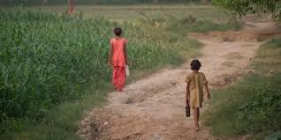

Under the Swachh Bharat Mission Gramin (SBM-G), rural Uttarakhand and rural Haryana have declared themselves as the 4th and 5th Open Defecation Free (ODF) States of India.

- The two today joined the league of Sikkim, Himachal Pradesh and Kerala, which were the first three states to be declared ODF.

- Nationally, the sanitation coverage has increased from 42% to over 64% in just two and a half years since the launch of SBM.

- Uttarakhand has 13 districts, 95 blocks, 7256 gram panchayats and 15751 villages while Haryana has 21 districts, 124 blocks, and 6083 gram panchayats all of which have declared themselves as ODF in formal declarations in Dehradun and Chandigarh, respectively.

India Signs Loan Agreement of World Bank for USD 240 million and USD 160 Million from AIIB

A Loan Agreement for part funding of USD 240 million from the World Bank (IBRD) and USD 160 Million from AIIB (60:40 ratio) for “24X7 Power for All in Andhra Pradesh Project” was signed here today by Shri Raj Kumar, Joint Secretary (MI), Department of Economic Affairs,Ministry of Finance on behalf

of the Government of India, Mr. Hisham Abdo, Operations Manager and Acting Country Director, World Bank (India) on behalf of the World Bank and Mr. D.J. Pandian Vice-President & Chief Investment Officer, AIIB.

- The Program Implementing Entity Agreement was signed by Mr. K. Ranganatham, Adviser (Energy), Department of Energy, Government of Andhra Pradesh on behalf of Government of AP, the Country Director (India) on behalf of the World Bank and the Vice President and Chief Investment Officer, AIIB on behalf of the AIIB.

- Total Cost of the project is USD 570 million, out of which USD 240 million is from World Bank (IBRD) and USD 160 million from AIIB. The rest will be counterpart funding from GoAP.

- The objective of the project is to increase the delivery of electricity to customers and to improve the operational efficiency and system reliability in distribution of electricity in selected areas in Andhra Pradesh.

EPFO signs MoU with HUDCO under new Housing
Scheme of EPF & MP Act-1952
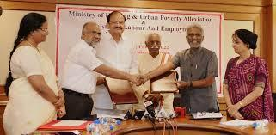

Dr. V.P. Joy, Central Provident Fund Commissioner and Dr. M. Ravi Kanth, CMD HUDCO signed a Memorandum of Understanding (MoU) in the august presence of Union Minister of Urban Development, Housing & Urban Poverty

Alleviation, Shri M. Venkaiah Naidu and the Minister of State (Independent

NATIONAL
NEWS

NATIONAL
NEWS

NATIONAL

NEWS

Charge), Labour & Employment, Shri Bandaru Dattatreya for facilitating “Housing for All by 2022” here today.

- By taking one step forward to achieve Hon‟ble Prime Minister Shri Narendra Modi‟s vision of Housing for all by 2022, EPFO has amended EPF Scheme

1952 vide Gazette notification No. G.S.R. 351(E) dated 12th April, 2017 to provide assistance in acquiring affordable houses to the EPF members by allowing withdrawal from the provident fund to the extent of 90% of the total PF accumulation and also facilitating payment of installment of housing loan.

- The major objective of this scheme is to assist in building houses for workers integrating with housing programmes of the Central and State Governments.

Ministry of Mines Invites Science and Technology
Project Proposals
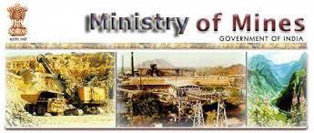

Projects are invited from Academic Institutions, Universities, National Institutes and R&D Institution recognized by the Department of Scientific and Industrial Research, Government of India, for upto 3 years duration in the following thrust areas which have direct bearing on mineral sector, applied and sustainable aspect of mining

and industrial applications:

- The broad thrust areas for supporting Research in Mining are given below:
- Prospecting/exploration for strategic rare and rare earth minerals.

- Development of new technology for mineral exploration and mining on land and deep sea to locate and exploit new mineral resources.

- Research in mining methods. This includes rock mechanics, mine designing, mining equipments, energy conservation, environmental protection and mine safety.

- Improve efficiency in process, operations, recovery of by-products and reduction in specification and consumption norms.

- Research in metallurgy and mineral beneficiation techniques to utilize lower grade and finer size ores.

- Extraction of value added products from mine waste, plant tailings etc.
- Development of new alloys and metal related products, etc.

Jitendra Singh launches Online Software for
Departmental Proceedings
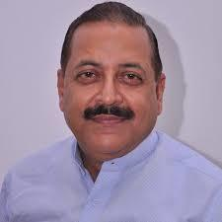

The Union Minister of State (Independent Charge) Development of North-Eastern Region (DoNER), MoS PMO, Personnel, Public Grievances & Pensions, Atomic Energy and Space, Dr Jitendra Singh launched the online Software for Departmental Proceedings, here today.

NATIONAL

NEWS

NATIONAL

NEWS

- Speaking on the occasion, Dr Jitendra Singh complemented the Department of Personnel and Training (DoPT), CVC and other departments for their collective efforts in this direction.

- He said that the Government under the leadership of Prime Minister Shri Narendra

Modi has been working on the principles of „maximum governance, minimum government‟, transparency with accountability & citizen centricity and zero tolerance against corruption.

- The Minister said that the aim of the software is to see that the proceedings are done against corrupt officers and the honest officers are not put to harm due to inordinate delays.

- He said that the bureaucracy is the tool of governance and the aim of the government is to provide work-friendly environment to the officers.

- He said that the software will check that the honest officers are not intimidated and it will encourage the transparent functioning in the Government.

- It will ensure that the malpractices are not spared and the good practices are not punished, he added.

- He said that the efforts have been made to complete the disciplinary enquiry within 2 years.

- He said that reducing the timeline in completion of disciplinary proceedings will give faster relief to the honest officers.

Central Government issues commemorative postage stamps on 250th anniversary of 'Survey of India'

Survey of India strives to keep India among the best surveyed countries in the world-Manoj Sinha Commemorative postage stamp released on 250th anniversary of Survey of India
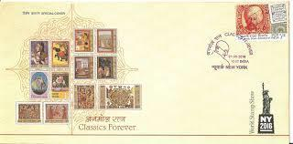

- Minister of Communications Shri Manoj Sinha today said that Survey of India has has met the challenges of surveying the indomitable Himalaya, blazing deserts and animal infested jungles.

- The Department is continuously striving to keep abreast of modern technology and has successfully entered the era of Digital Mapping and Geographic Information Systems.

- Shri Sinha was speaking here after releasing a set of two commemorative postage stamps and a miniature sheet on Survey of India" on the occasion of its 250th anniversary.

- He said that the Survey of India, fondly called the Department by its members is built on solid foundations, strong traditions and deep roots, keeps striving to keep India among the best surveyed countries in the world, adopting the latest technologies to meet new challenges and always living up to its motto: A Setu Himachalam i.e. 'From Setu to the Himalaya' (covering entire India).

- Shri Sinha said that the Department of Posts issues Commemorative postage stamps on Institutions that have a national or International stature or have made national/international contribution.

- He said that the origin of Survey of India can be traced back to Year 1767, when Major James Rennell was appointed as the Surveyor General of Bengal.

NATIONAL

NEWS

- It is the oldest scientific department in India and one of the oldest survey establishments in the world. Survey of India also has the distinct honour of printing the first Postage Stamp of India and the first copy of the Constitution of India.

- The Minister said that the officers and staff of the Survey of India have to pioneer untrodden lands for others to follow and build upon.

Presidential election: Meira Kumar is
Opposition candidate

The Opposition unanimously selected former Lok Sabha Speaker Meira Kumar on Thursday as its candidate for the presidential election next month.
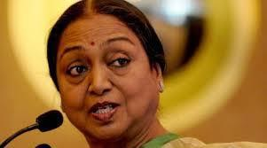

- If the decision to challenge the BJP nominee, Ram Nath Kovind, sprang from a desire to jointly fight “an ideological battle” against the ruling Bharatiya Janata

Party (BJP), in the lead-up to 2019, the fact that Ms. Kumar is from Bihar played a role in her selection.

- With the defection of the Nitish Kumar-led Janata Dal (United) to the BJP camp, a sore point with the Opposition leaders who gathered at the Parliament Library, there was a clear sense though not stated that the presence of Ms. Meira Kumar in the fray might embarrass the JD(U). Especially as the Bihar Chief Minister had stressed he was backing the Uttar Pradesh-born R.N. Kovind as he was Governor of Bihar.

- RJD leader Lalu Prasad Yadav later said he would ask Mr. Nitish Kumar to change his mind and back the daughter of Bihar.

- Ms. Kumar, as senior Congress leader Ghulam Nabi Azad pointed out, is the daughter of freedom fighter, former Union Minister and Dalit icon Jagjivan Ram, and has an impressive CV she has been a five-time Lok Sabha member, Lok Sabha Speaker, Union Cabinet Minister and has had a stint in the Indian Foreign Service.

NATIONAL

NEWS

