Ministry of Electronics and Information Technology

launched website
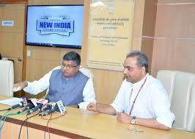

In order to ensure preparedness for GST implementation from 1st of July 2017, Ministry of Electronics & Information Technology has launched a dedicated Webpage for facilitating taxpayers with regard to addressing issues related to Information Technology Services & Electronics goods.

- The Webpage can be accessed through Ministry‟s Web Portal http://meity.gov.in/ .

- Individuals, Companies and Entrepreneurs in IT & Electronics sector can visit the webpage for sector-specific information.

- The web page also enables filing of grievances in relation to implementation of GST..

Ministry of Tourism releases ‘Compendium on guidelines for Ayush facilities’
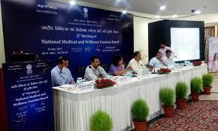

The Ministry of Tourism has released the „Compendium on Guidelines for Ayush Facilities‟ here today.

- The National Medical & Wellness Tourism Board under the chairmanship of Minister for Tourism Dr. Mahesh Sharma has been repeatedly stressing on the need for benchmarking of facilities offered by the various service providers in the field of Medical and Wellness Tourism on the basis of globally accepted standards.

- The constant endeavour of the Ministry of Tourism has been to promote institutions and processes that have achieved such standards in order to provide excellence in service quality.
- The compendium includes accreditation available for the following facilities:

- Ayurveda Hospitals
- Yoga and Naturopathy Hospitals
- Unani Hospitals
- Sidha Hospitals
- Homeopathy Hospitals
- Panchkarma Clinics
- Wellness Centres

NATIONAL

NEWS

NATIONAL

NEWS

NCERT’s National Yoga Olympiad- 2017 Concludes

A 3-day National Yoga Olympiad concluded at Talkatora stadium, New Delhi yesterday, with distribution of Prizes to the children of winner states by the Chief Guest Shri Upendra Kushwaha, MoS, Ministry of HRD.
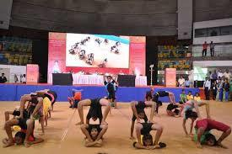

- The Guest of Honour on the occasion was Dr. H.R Nagendra, Chancellor of S VYASA University, Bangalore.
- The awards were given in four categories –

- Upper Primary (Girls) – The Gold medal was bagged by the Gujarat team, the Silver medal by the Delhi team and Bronze medal by the Haryana team.

- Upper Primary (Boys) – The Gold medal was bagged by the Delhi team, the Silver medal by the Gujarat team and Bronze medal by the Tamil Nadu team.

- Secondary (Girls) – The Gold medal was bagged by the Delhi team, the Silver medal by the Gujarat team and the Bronze medal by the Karnataka team.

- Secondary (Boys) – The Gold medal was bagged by the Haryana team, the Silver medal by the Delhi team and the Bronze medal by the Manipur team.

Union Sports Minister Vijay Goel and tennis legend Vijay Amritraj take part in curtain raiser for second edition of
Slum Daud
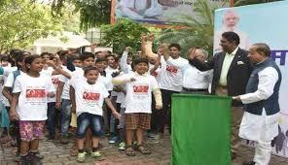

Minister of State (I/C) for Youth Affairs and Sports Vijay Goel here today led the curtain raiser of the second edition of the Slum Daud.

- Chief Guest for the event was tennis legend Vijay Amritraj.

- The first edition of the Slum Daud was held on 26 May in which 5000 youngsters from various slums in Delhi participated wholeheartedly.

- The Slum Yuva Daud is part of the Adopt Slum Campaign initiated by the Ministry of Youth Affairs & Sports and Nehru Yuva Kendra Sangathan.

- Interacting with the media Shri Goel said, “This would enable us to gather the youth and know about their skills and ideas.

- We would organize mini-fests in slums with the themes of Swachhta, Digital
India, Beti Bachao Beti Padao etc.”

- “We will aim at creating model slums and create groups of youth who will work as agents of change to work for the development of their respective slums/areas”, Goel added.

NATIONAL

NEWS

NATIONAL

NEWS

10th Anniversary Celebrations of Indo-Russian
Partnership in Science and Technology

- MOU on the India-Russia unified technology

assessment and accelerated commercialization programme, was concluded in Moscow in 20th June 2017, by the Secretary, Department of Science & Technology (DST) Professor Ashutosh Sharma and Director General,

Foundation for Assistance to Small Innovative Enterprises (FASIE), Russia Dr. Sergey Polyakov.

- The MOU aims at facilitating support enterprises to improve their global competitiveness through international cooperation, innovative activities and technology transfer.

- The two agencies (DST and FASIE) will link the Indian and Russian organisations and institutions to develop user-friendly and easy mechanisms for assisting companies and research entities to jointly develop technology collaboration and joint projects.

INDIA PAVILION at the Biotechnology Innovation
Organization (BIO) International Convention &
Exhibition San Diego, USA

The Indian Pavilion at BIO International Convention & Exhibition 2017, San Diego was inaugurated by the Minister of State for S&T and Earth Sciences, Mr. Y S Chowdary.

- The MAKE IN INDIA theme has been emphasized in the Indian Pavilion.

- Inaugurating the Pavilion, the Minister stated that the positive discussions during BIO will lead to a lot of new opportunities for Indian start-up companies in Science & Technology and will also boost the confidence of international stakeholders in India‟s biotech sector.

- More than 30 start-ups, companies, state governments, biotech parks and research institutes are exhibiting at the India Pavilion.

- BIO has attracted over 15000 attendees from over 60 countries and provides a global opportunity at a single location.

- The Minister also released a 60-page India Biotech Handbook 2017, showcasing the strengths of India‟s fast-growing $42 billion Bio-Economy.

INTERNATIONAL

RELATIONS

INTERNATIONAL

RELATIONS

Qatar Airways announced World's Best Airline at 2017

Skytrax World Airline Awards
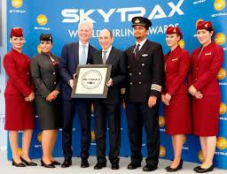

Qatar Airways on 20 June 2017 was announced the

World‟s Best Airline at the SKYTRAX 2017 World Airline
Awards.

GLOBAL NEWS

- Qatar Airways was voted Best Airline by travellers across the world in the annual passenger survey.

- The Doha based carrier has now won the prestigious Airline of the Year title for a fourth time.
- Qatar Airways also won the World‟s Best Business Class, the World‟s Best
First Class Lounge and the Best Airline in the Middle East awards.

- On the other hand, Air Asia won awards for being the Best Low-Cost Airline in Asia for a month year in the row, and also as World's Best Low-Cost Airline Premium Cabin 2017.

- World's Best Low-Cost Airline: AirAsia
- Best Low-Cost Airline in Asia: AirAsia
- Best Airline in Central Asia / India: Air Astana
- Best Regional Airline in Asia: Bangkok Airways
- Best Low-Cost Airline in Central Asia / India: Indigo
- Best Airline in Asia: Singapore Airlines

China launched train with virtual track
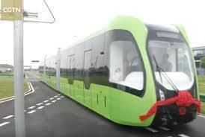

China has unveiled world‟s first train that runs on a | GLOBAL NEWS
virtual track making use of sensor technology instead
of metal rails.

- The new trains are non-polluting as they are battery powered.

- The train is capable of reaching a top speed of 70 kmph and can travel a distance of 25 km by just charging for 10 minutes.

- The train which is only about 32 metres long can carry up to 307 passengers.

- The new trains are fitted with sensors which are capable of detecting the dimensions of the road permitting it to follow the routes without the need for metal rails.

- So it can run without the presence of tracks. The new trains will make use of rubber wheels on a plastic core and can be automatically guided without rails.

- This new technology has been copyrighted by the Chinese rail corporation.
- The train will be rolled out for public use in 2018. It will be launched in the

Chinese city of Zhuzhou in a bid to help to deal with traffic in the area.

- The new train is expected to have a lifespan of around 25 years.

