Election Commission to Launch First Time Nationwide

“Voter Registration Reminder” on Facebook

Election Commission of India (ECI) is launching a „Special Drive to enrol left out electors, with a special focus on first time electors from 1st July , 2017 , so as to move in the direction of Commission‟s motto that 'NO VOTER TO BE LEFT BEHIND‟.
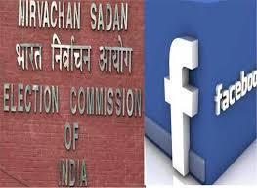

- In order to reach out to maximum eligible voters, the ECI is collaborating with

Facebook to launch first Nationwide “Voter Registration Reminder” on 1st July ,2017 . With over 180 million people in India on Face book, the „Register Now‟ button is designed to encourage Indian citizens to register themselves with the Election Commission of India.

- On 1st July, a notification of the “voter registration reminder” will be sent to people on Facebook in India who are eligible to vote.

- The reminder will be sent out in 13 Indian languages - English, Hindi, Gujarati, Tamil, Telugu, Malayalam, Kannada, Punjabi, Bengali, Urdu, Assamese, Marathi and Oriya.

- This is the first time Facebook's voter registration reminder has been rolled out across India. In 2016 and 2017, Chief Electoral Officers made such efforts at state level during their respective state elections.

The Central Board of Direct Taxes (CBDT) entered into Five Unilateral Advance Pricing Agreement

with Indian taxpayers

The Central Board of Direct Taxes (CBDT) entered into Five Unilateral Advance Pricing Agreement with Indian taxpayers during June, 2017. A Bilateral Advance Pricing Agreement (involving United Kingdom) was also signed during the month.
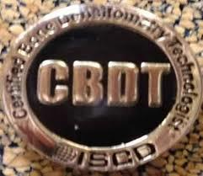

- The APA Scheme endeavours to provide certainty to taxpayers in the domain of transfer pricing by specifying the methods of pricing and determining the arm‟s length price of international transactions in advance for the maximum of five future years.

- Further, the taxpayer has the option to rollback the APA for four preceding years, as a result of which, tax certainty for a total period of nine years is provided. Since its inception, the APA scheme has attracted tremendous interest among Multinational Enterprises (MNEs).

- The APAs signed in June, 2017 pertain to healthcare, information technology and gaming/animation (media) sectors of the economy.

- The number of Unilateral APAs signed in the current financial year is now nine and the number of Bilateral APAs signed in the current financial year is one .

NATIONAL
NEWS

NATIONAL
NEWS

- With this, the total number of APAs signed since the commencement of the program till date stands at 162 (Unilateral-150 and Bilateral-12). The CBDT expects more APAs to be signed in the near future.

Launch of National Biopharma Mission
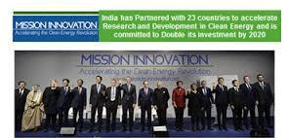

The first ever Industry-Academia mission to accelerate biopharmaceutical development in India will be formally launched by the Cabinet Minister for Science and Technology, Earth Sciences, Environment, Forests and Climate Change, Dr. Harsh Vardhan in New Delhi on 30th June 2017.

- The program named Innovate in India (i3) will witness an investment of USD 250 million with USD 125 million as a loan from world Bank and is anticipated to be a game changer for the Indian Pharmaceutical industry.

- It aspires to create an enabling ecosystem to promote entrepreneurship and indigenous manufacturing in the sector.

- India has been an active player in the pharmaceutical industry and has contributed globally towards making life saving drugs and low cost pharmaceutical products accessible and affordable for those in need.

- Be it the Rotavirus vaccine, heart valve prosthesis or affordable insulin, India has been a forerunner in these and many more. Despite, these advances Indian biopharmaceutical industry is still 10-15 years behind their counterparts in the developed countries and faces stiff competition from China, Korea and others.

- The lacuna primarily exists due to disconnected centers of excellence, less focus on translational research and staggered funding.

- There was an immediate need felt to focus on consolidated efforts to promote product discovery, translational research and early stage manufacturing in the country to ensure inclusive innovation.

Dr. Harsh Vardhan and Shri Dharmendra Pradhan inaugurate Swasth Saarthi Abhiyaan and Fuel Conservation Workshop

Union Minister for Science and Technology and Earth Sciences and Environment, Forest and Climate Change, Dr. Harsh Vardhan and Minister of State (I/C) for Petroleum and Natural Gas, Shri Dharmendra Pradhan, together, inaugurated the Swasth Saarthi Abhiyaan (SSA) today at Siri Fort Auditorium.
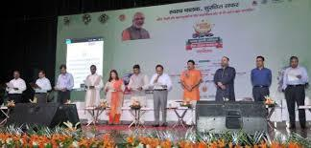
- The Swasth Saarthi Abhiyaan (SSA) is a two month long mega campaign focusing on providing preventive healthcare to the auto, taxi and bus drivers of the region.

- SSA, an initiative of Indraprastha Gas Limited (IGL), was inaugurated in the presence of various dignitaries including Members of Parliament, Officials of Delhi Police and other Senior Officials of the Ministry.

NATIONAL
NEWS

NATIONAL

NEWS

- The SSA event is a unique initiative to address the major issues being faced by public transport drivers of the region, with almost all of them being users of CNG.

- Shri Dharmendra Pradhan in his address said that the drivers in the capital region are partners in the growth story of gas used as fuel in vehicles. CNG is used in vehicles for transport, domestic use, autos etc. He said that approx.. 4.5 Lakh vehicles which use CNG contribute to the Rs 3000 Cr business of IGL.

- He said that new aim should be to increase this business from Rs 3000 Cr to Rs 30,000 Cr.

22 Cabinet decisions taken in last 3 years in E&P

Minister of State (I/C) for Petroleum and Natural gas, Shri Dharmendra Pradhan, launched the National Data Repository (NDR) and Open Acreage Licensing Policy (OALP) under the progressive, market driven Hydrocarbon Exploration and Licensing Policy (HELP) of Government of India in New Delhi today.

- Speaking at the event, Shri Dharmendra Pradhan said that the launch is a historic occasion in the history of India‟s Hydrocarbon Industry.

- Hon'ble Prime Minister gave the mandate for a modern, progressive, investor friendly world class policy for the next bidding round.

- He said that with the experience of several litigations and not very encouraging production output from NELP rounds, the Ministry decided not to go for incremental policy change but to have a completely new policy.

- Hydrocarbon Exploration and Licensing Policy (HELP) is an outcome of this.

Indian bodybuilder Bhumika Sharma wins
Miss World in Venice

Dehradun bodybuilder Bhumika Sharma has won the Miss World title in Venice.

- Bhumika, who was one of the 27 Indian participants who were in the competition, won the maximum points in three categories i.e., individual posing, body posing and fall.

- This eventually won the gold medal at the world championship in Venice last week.

- Bhumika won the title ahead of a total of 50 bodybuilders from around the world, according to Hindustan Times.

- Bhumika also said that she has now set her eyes on the Miss Universe Championship that will be held in UK in December.

NATIONAL
NEWS

AWARDS

- According to the Hindi publication of the Hindustan Times, Bhumika has been in the sport for the past three years.

- Her mother Hansa Manral Sharma is the head coach of Indian weightlifting team while her father Vishwavijay Sharma is a businessman.

- Her parents wanted her to take up shooting but a chance meeting with a bodybuilding coach had convinced her to take up a career in the sport.

Dr. Manoj Soni takes Oath as Member, UPSC

Dr. Manoj Soni, former Vice Chancellor of Dr. Babasaheb Ambedkar Open University, took the Oath of Office and Secrecy as Member, Union Public Service Commission (UPSC) here today.
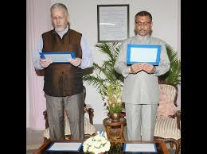

- The Oath was administered by the UPSC Chairman Prof. David R. Syiemlieh.

- Born on 17th February, 1965, Dr. Soni, a scholar of Political Science with specialization in International Relation Studies, earned his doctorate in "Post-Cold War International Systemic Transition and Indo-US Relations" from Sardar Patel University.

- Dr. Manoj Soni has been the youngest-ever Vice Chancellor in independent (India).

- Dr. Soni is the recipient of several awards and recognitions including the rare honour of "Honorary Mayor-President of the City of Baton Rouge" by Mayor-President of Baton Rouge, Louisiana, USA and World Education Congress Global Award for Distance Learning Leadership.

Facebook now has 2 billion monthly users

Thirteen years after launching and less than five years after hitting 1 billion, Facebook now has 2 billion monthly active users.
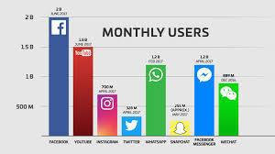

- Facebook wants people to celebrate with a personalized “Good Adds Up” video they can make and share here. Meanwhile, Mark Zuckerberg played it cool with this brief announcement message.

- Two billion makes Facebook the largest social app in terms of logged-in users, above YouTube‟s 1.5 billion, WeChat‟s 889 million, Twitter‟s 328 million and Snapchat‟s estimated 255 million (extrapolated from its

December 2015 ratio when it had 110 million daily and 170 million monthly users).

- Beyond YouTube, only Facebook‟s other apps have more than 1 billion, including WhatsApp and Facebook Messenger, with 1.2 billion each. Instagram might soon join that club as it recently rocketed past 700 million.

APPOINTMENTS

GLOBAL

NEWS

- Despite Facebook‟s size and age, at 17 percent its user count is growing as fast or faster than any year since 2012. And people aren‟t using it less either.

- In fact, 66 percent of Facebook‟s monthly users return each day now compared to 55 percent when it hit 1 billion. If the teenaged social network isn‟t as cool to teenagers any more, it‟s not showing in the big metrics.

