Piyush Goyal, Minister of State (Independent Charge) for Power, Coal, New and Renewable Energy and Mines

chairs 5th Geoscience Advisory Council Meeting
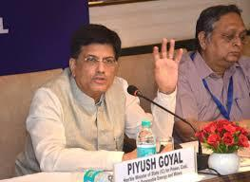
Shri Piyush Goyal, Minister of State (Independent Charge) for Power, Coal, New and Renewable Energy and Mines, addressed the 5th Geoscience Advisory Council (GAC) Meeting in New Delhi today.

- Mines Secretary Shri Arun Kumar, DG GSI Shri M Raju and other Ministries’ Official members, Scientific Institutions and Non-Official members of the GAC participated in the daylong deliberations.

- The 5th GAC discussed issues related to Geophysical techniques for exploration of concealed/deep seated mineral deposits, Mineral System Research and advanced techniques for exploration of subsurface mineral deposits, and the strategy for exploration, augmentation of mineral resources and mining of Rare Earths/Rare Minerals and other strategic resources.

- Shri Piyush Goyal @PiyushGoyal, Minister of State (Independent Charge) for Power @MinOfPower, Coal @CoalMinistry, New and Renewable Energy @mnreindia and Mines @MinesMinIndia, asked the scientific community working in the field of geosciences and mineral system research to add value to the mineral wealth of the country especially in the area of strategic and critically important metals and minerals.

- At the same time there has to be a harmony between wealth creation and preservation of ecology and environment for sustainable development.

25 Ministries/ Departments to turn into e-office by end of June, says Dr. Jitendra Singh

The Union Minister of State (Independent Charge)
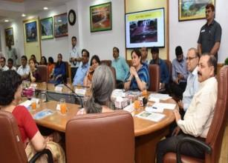
Development of North-Eastern Region (DoNER), MoS

PMO, Personnel, Public Grievances & Pensions, Atomic Energy and Space, Dr Jitendra Singh visited the office premises of Department of Administrative Reforms and Public Grievances (DARPG) here today, to review the
implementation of the Swachhta Action Plan.

- The DARPG and Department of Pension and Pensioners’ Welfare are observing the Swachhta Pakhwada from 16th-30th June, 2017.

- On the occasion, Dr. Jitendra Singh complimented both the Departments for undertaking various Swachhta related activities during this Pakhwada and also expressed happiness that the two Departments are working together as one team.

- He said that the habit of cleanliness should be practised by all and it should be the responsibility of everyone to keep their surroundings clean.

- Highlighting the steps taken by DARPG, he said that 25 Ministries/ Departments will be turned into e-office by the end of this month.

NATIONAL
NEWS

NATIONAL
NEWS

- He also said that there has been an increase of a whopping 6000%, in the number of e-files with 4,62,000 e-files generated in 2017, compared to 8,000 e-files last year.

- Dr Jitendra Singh said under the guidance of Prime Minister Shri Narendra Modi, the Departments are committed to provide maximum Governance to the public.

- He said that the process involved in the Civil Services Day has been completely transformed by DARPG in the last three years, as the participation and involvement of stakeholders has increased many folds.

- He said that DARPG is seen as the HR department of the Government of India. All good practices originate from this Department, he added.

- The Minister said that an MoU between India and Portugal on Cooperation in the field of Public Administration and Governance Reforms has been recently approved by the Cabinet.

Suresh Prabhakar Prabhu Lays the Foundation Stone for Final Location Survey of Bilaspur-Manali-Leh New

Broad Gauge Line Today

After the significant progress in the completion of the rail line in the state of Jammu & Kashmir, the Indian Railways endeavours to extend the socio-economic benefits of rail transportation to other remote areas and challenging terrains of the hilly states (HP & J&K) where development is scarce.
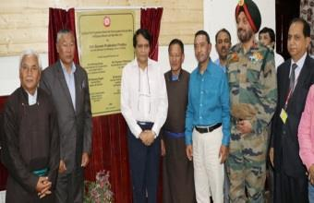
- Amongst the various socially desirable projects in the country, Bilaspur-Mandi-Leh Rail Line (route length 498 Kms) constitutes great significance.

- The project is of both strategic and economic, development and tourism importance, with its unique distinction being the highest railway track in the world.

- Minister for Railways Shri Suresh Prabhakar Prabhu laid the foundation stone for the Final Location Survey Of Bilaspur-Manali-Leh New Broad Gauge Line, at Leh today (27th June 2017) in the august presence of distinguished guests on the occasion.

- Shri R.K. Kulshrestha General Manager, Northern Railway and other Senior Railway officials were also present in the function.

- Leh is the most important town in Ladakh region of J&K State having approximately 1.5 lakhs population.

- It has a high footfall of Indian & Foreign tourists each year. The district Leh is the second largest district in the country with elaborate Army Establishments and is the Headquarter of 14 corps.

- The region being a cold desert, the temperature during the winter months (Oct-Mar) plummets down to well below freezing point.

- The road connectivity to this area is gets cut off from other parts of country due to heavy snowfall, thus necessitating all weather rail connectivity both for strategic as well as socio-economic needs.

NATIONAL
NEWS

Highest Number of Divyangjans will be felicitated by Prime

Minister at Rajkot Samajik Adhikarita Camp on 29th June 2017

The biggest ever Samajik Adhikarita Shivir for distribution of Aids & Assistive Devices to Divyangjan (PwDs) will be organized at Rajkot (Gujarat) on 29th June 2017 by the Department of Empowerment of Persons with Disabilities (Divyangjan), Ministry of Social Justice and Empowerment, Government of India through ALIMCO, Kanpur, a CPSU under the Department.
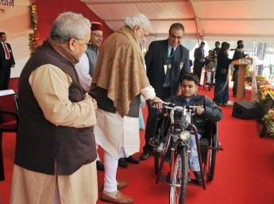
- The camp will be held at Race Course Ground in Rajkot, Gujarat where assistive Aids and Appliances will be distributed under ADIP scheme of Govt. of India to Divyangjans in the august presence of the Prime Minister Shri Narendra Modi, Chief Minister of Gujarat Shri Vijay Rupani and Union Minister of Social Justice and Empowerment Shri Thaawarchand Gehlot.

- Besides Union Ministers of State for Social Justice and Empowerment Shri Ramdas Athwale, Shri Krishna Pal Gurjar, Shri Vijay Sampla, Minister of Gujarat for Social Justice and Empowerment, Women and Child Development Shri Atmaram Parmar, Member of Parliament Shri Mohanbhai Kundariya and other State dignitaries will also be present during the function.

- The camp is being conducted under the ADIP Scheme of Govt. of India. The scheme is in vogue since 1981 and has been revised with effect from 01st April 2014.

- The main objective of the scheme is to provide latest and modern aids mainly manufactured by Artificial Limbs Manufacturing Corporation of India (ALIMCO) and distributed by National Institutes, District Disability Rehabilitation Centres, State Handicapped Development Corporations, other local bodies and NGOs. These aids are being given to the Divyangjans to promote their physical, social and psychological rehabilitation.

World Bank clears $250 million loan for Skill
India mission

The World Bank has cleared a $250 million loan for making Indian youth more employable through reskilling, in a move that is seen to aid the Skill India mission.
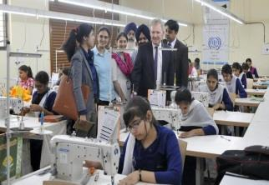

- The multilateral lender is keen to support the Indian government in its efforts to better equip the young workforce with employable skills.

- It said the support will help the youth contribute to India's economic growth and prosperity.Under the programme, adults in 15-59 years of age, underemployed or unemployed, will get the skill training.

- It will also include the 1.2 crore youngsters in the age group of 15-29 years who are entering the labour market every year.

NATIONAL

NEWS

NATIONAL
NEWS

- The programme has a mandate to provide placement and entrepreneurship opportunities to women and increase their exposure to skill training.

- The Washington-headquartered World Bank's SIMO is a six- year programme in support of the Indian government's National Policy for Skill Development and Entrepreneurship (2017-23).

- SIMO will be implemented through the National Skill Development Mission and will specifically target labour market entrants.According to an official skill gap analysis, India will require an additional 109 million skilled workers in 24 key sectors by 2022.

- India continues to be on its path of structural reforms and a higher-skilled labour force can potentially serve as a catalyst in transforming it into a competitive middle income country, Ahmad said.

Halle Open: Roger Federer brushes past Alexander Zverev to win record 9th title
Swiss great Roger Federer thrashed Alexander Zverev to win his ninth title at the Wimbledon warm-up tournament in Halle on Sunday.

- The top seed lost his first match of the grass-court season last week in Stuttgart to Tommy Haas, but was in imperious form all week at Halle, culminating in the 6-1, 6-3 final victory over the home favourite Zverev.

- Federer will head into Wimbledon, which starts on July 3, as favourite to win an outright record eighth title.

- Italian Open champion Zverev had won all three of his previous finals this season, but was blown away by a vintage performance from the 18-time major champion in only 53 minutes.

- The 35-year-old Federer, who skipped the entire clay-court season in order to be fully fit for Wimbledon, has still only lost two matches this year en route to four titles, including the Australian Open in January.

6th Joint Trade Committee Meeting between India and Myanmar

The 6th India – Myanmar Joint Trade Committee (JTC) Meeting co-chaired by Smt. Nirmala Sitharaman, Minister of Commerce & Industry from India and Dr. Than Myint, Union Commerce Minister from Myanmar was held on 27th June 2017 at New Delhi.
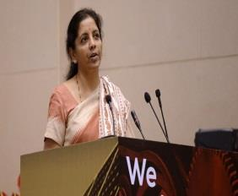
- The Joint Trade Committee plays a key role in facilitating issues related to enhancement of the bilateral economic partnership between the two countries.

- Addressing the meeting The Minister stated that both countries have long history of shared religious, linguistic and ethnic ties.

SPORTS

International

Relation

- Myanmar is India’s gateway to Southeast Asia and ASEAN with which India is seeking greater economic integration through ‘Act East’ Policy. Myanmar shares a long land border of over 1600 Kms with India as well as a maritime boundary in the Bay of Bengal.

- Our bilateral relationship has been further strengthened by the high level exchanges between our countries.

- Prime Minister of India visited Myanmar in November 2014 for the Twelfth India-ASEAN Summit. State counsellor of Myanmar visited India in October 2016

- Stating that Trade and Commerce play a significant role in the bilateral relationship of the two countries, Smt.Sitharaman noted that India’s trade with Myanmar grew by 6.01% from USD 2.05 bn in 2015 -16 to USD 2.18 bn in 2016-17.

- The total export achieved in 2016-17 was 1.11 USD Billion, reflecting an annual growth of 3.79%. The import stood at 1.06 USD Billion showing a growth of 8.43%.

Kalraj Mishra Gives Away National Awards for MSME 2015
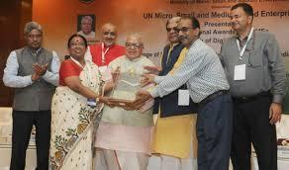
National Awards for MSME 2015 was organized here today.
Shri Kalraj Mishra, Union Minister for MSME gave away the

MSME Awards 2015.

- Since the United Nations has declared 27th June as the UN Day for MSMEs, the Ministry of Micro, Small and Medium Enterprises has selected this day for distributing National Awards to Micro, Small and Medium Entrepreneurs for their outstanding performance, to express the gratitude of the Government to the achievers in this field which is so important for the national economy.

● Shri Giriraj Singh and Shri Haribhai P. Chaudhary, Ministers of State for | AWARDS
MSME were also present to grace the occasion.

- Shri KK Jalan, Secretary MSME, Shri Surendra Nath Tripathi, Development Commissioner, Shri. Vinai Kumar Saxena, Chairman, KVIC, Shri C.P. Radhakrishnan, Chairman, Coir Board also were present on the occasion.

- On this occasion the Union Minister for MSME Shri Kalraj Mishra also launched ‘Digital MSME Scheme’ and handed over three Memorandums of
Understandings to SAP India, Intel and HMT respectively.

- These steps would further boost Ministry’s effort towards making the Digital

India Mission successful. The Digital MSME Scheme is revolving around Cloud Computing which is emerging as a cost effective and viable alternative in comparison to in-house IT infrastructure installed by MSMEs.

- In cloud computing, MSMEs use the internet to access common as well as tailor-made IT infrastructure including software for managing their business processes.

- Cloud computing is free from the burden of investment on hardware/software and infrastructural facilities. Therefore CAPEX converts into OPEX. This scheme would encourage MSMEs towards this new approach i.e. Cloud Computing for ICT adoption.

